Flowline & Isoline Machining

Introduction
The fifth sub-group of finishing options, Flowline Machining provides greater control of the projection direction of machining strategies onto a component. Applications include the machining of undercut features using special tooling and a more accurate finish for features positioned at complex angles to the tool axis.

The simplest way to understand the principle of projection machining is to think of beams of light radiating into or away from a defined source. A Surface projection projects the tool in or out along the normals of a selected surface.

Plane Projection Example

All five Projection Machining strategies can be set to machine undercut features if used with side mills. The following example shows an application using Plane strategy.

- Open the file heatsink.fm
- Run a 3D simulation

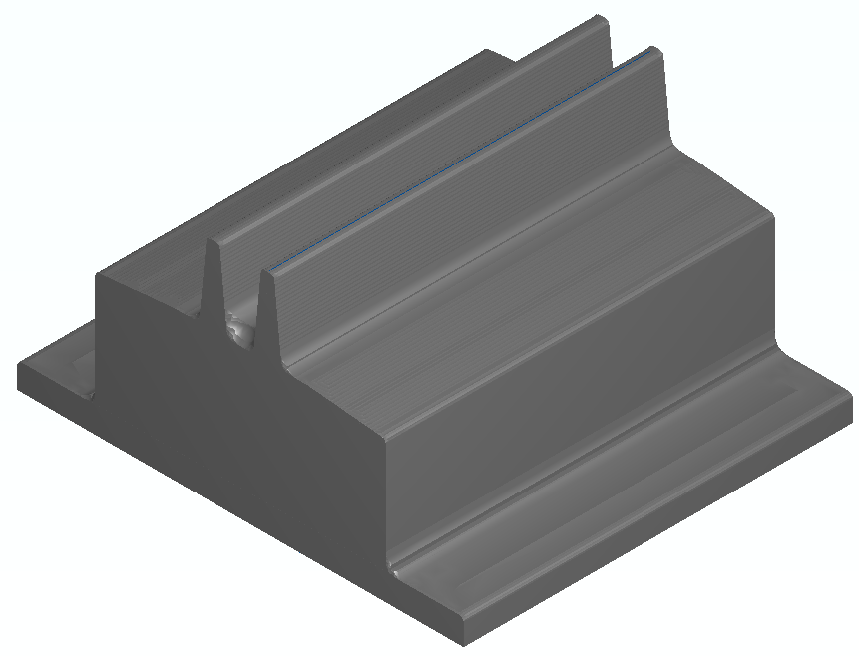

The part is set up to Z level rough and then use an interleave spiral to finish it. Now we must deal with the undercut regions.

- Double click on Milling_feature in the Part view and click on the Process tab.
- Click the Add new operation button
- Click Flowline as the finishing strategy and click Finish.
- Uncheck the two Z level operations in the process tab to suppress them.
- Make sure the flowline operation is listed as the last operation on the Process tab. If not, drag it to the bottom of the list.
- Click on the Flowline operation in the tree view.

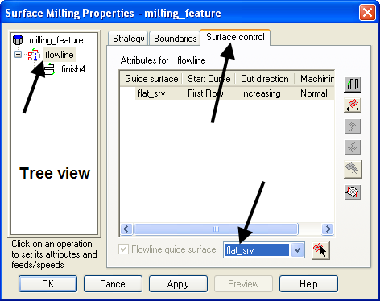

- Click on the Surface control tab.
- Select flat_srv from the Flowline guide surface drop down.
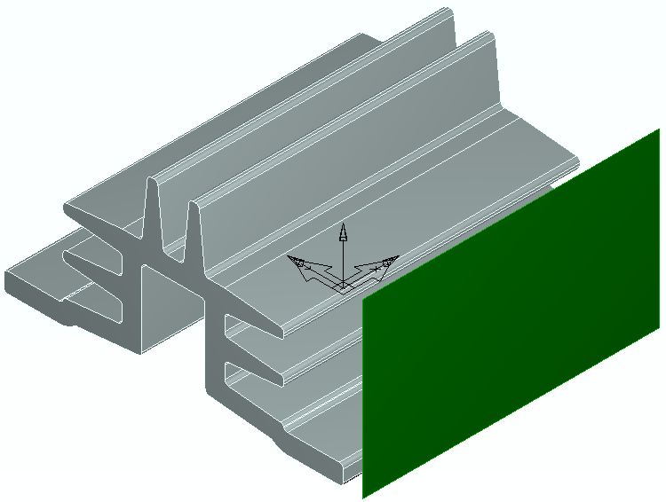

The selected surface is the plane to the front right of the above picture. The toolpath is projected from this plane, horizontally onto the model. The size and orientation of the plane governs which part of the model is machined.

- Click on the Finish4 operation in the tree view.

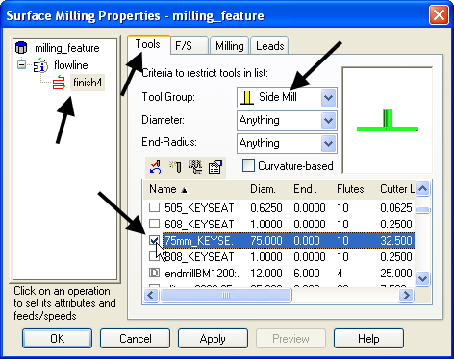

- Click on the Tools tab and set the Tool group to Side Mill.
- Check the 75mm_KEYSEAT cutter.

- YOU MUST ENSURE THIS TOOL IS SAVED WITH THE FILE.

- Click OK.
- Show a center line toolpath.
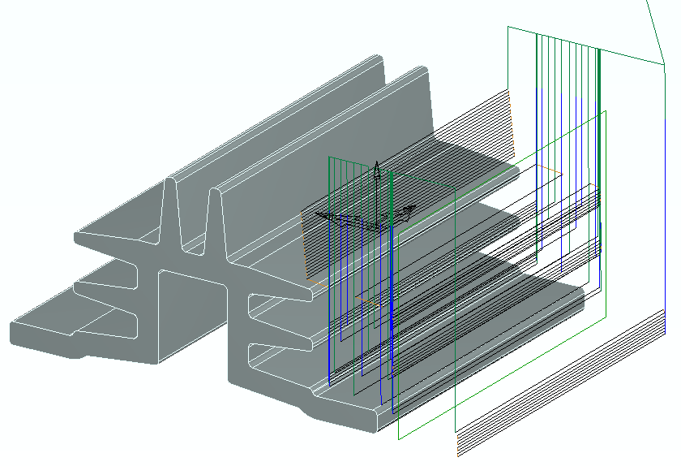

The tools are properly cutting the undercut regions but the tool is gouging through the fins when it retracts at the end of each pass. In this case suitable leads will be applied to easily rectify the problem.

- Double click on milling_feature in the Part View.
- Click on the Finish4 operation in the Tree View and click on the Leads tab.
- Set Use lead-in/out to On all stepovers, plunges & retracts.
- Change the Lead-in/out plane to Horizontal.
- Click Use arc ramp-in/out and set the Ramp diameter to 150.
- Click on the milling_feature.
- Click on the Process tab and check all of the operations.
- Click OK and run a 3D simulation.
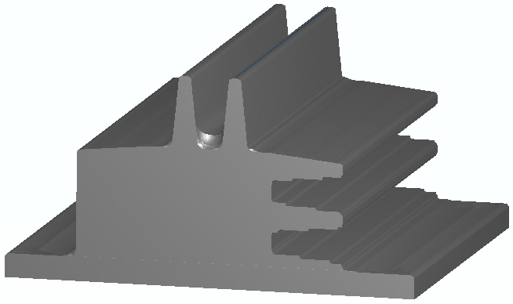

Leads have been used in this example to stop the toolpath gouging. They are an essential tool for use with most undercut machining applications.

One problem with these toolpaths is the surface finish on the nearly horizontal undercut surfaces. Since the toolpaths are a horizontal projection, the finish will always be poor in these regions.

Surface Projection Example

In this section a different surface will be used to provide a suitable finishing strategy with a more consistent stepover within the undercut regions. The flowline guide surface does not necessarily represent the true shape of the finished component. In practice it could be positioned inside, outside, or flush with the actual model surfaces to be machined. In this example the flowline guide surface is close to the existing model surface. It is the darker colored surface in the picture below.

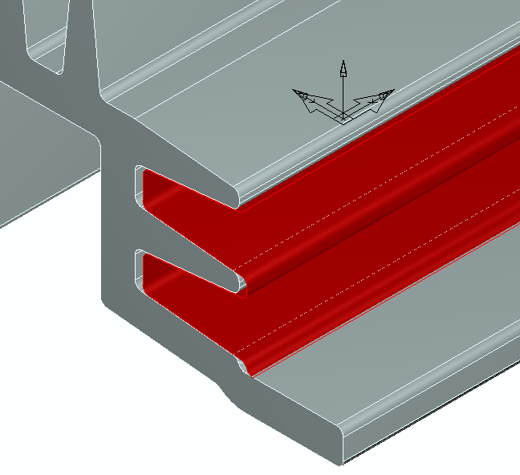

- Double click on the milling_feature in the Part View.
- Click on the flowline operation in the tree view.
- Click on the Surface control tab.
- Change the Flowline guide surface to wavy_srf.
- Click OK.
- Run a 3D simulation.
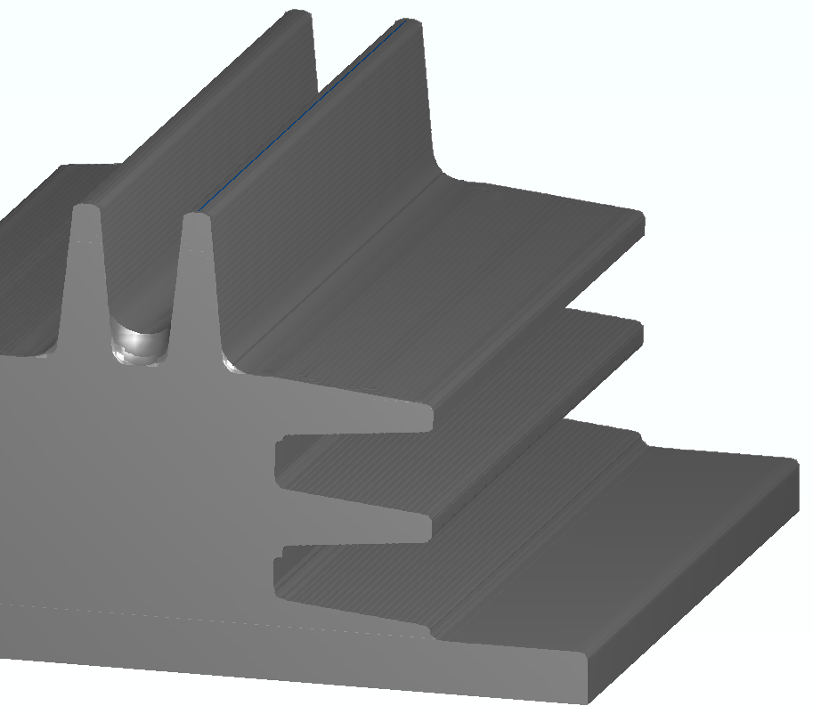

With the new flowline guide surface that better matches the shape of the undercut regions, the surface finish is much improved.

Non-undercut Flowline Example

The flowline technique is also applicable for toolpaths that are not axis aligned. As long as you can create a single surface that mimics that shape of the toolpaths you desire, flowline toolpaths are applicable.

This example represents the bottom of a blow mold for a PET soda bottle. In this example there is a curve in the center of the pocket. Our first step is to create a surface of revolution using the curve and then use that surface as the flow line guide surface.

- Open a millimeter milling document.
- Import the file blow mold.igs. The import wizard is displayed.
- Click Use the wizard to establish the initial setup location and stock size and click Next four times.
- On the stock dimensions page click Compute stock size from the size of the part and click Finish.
- Select an isometric view.
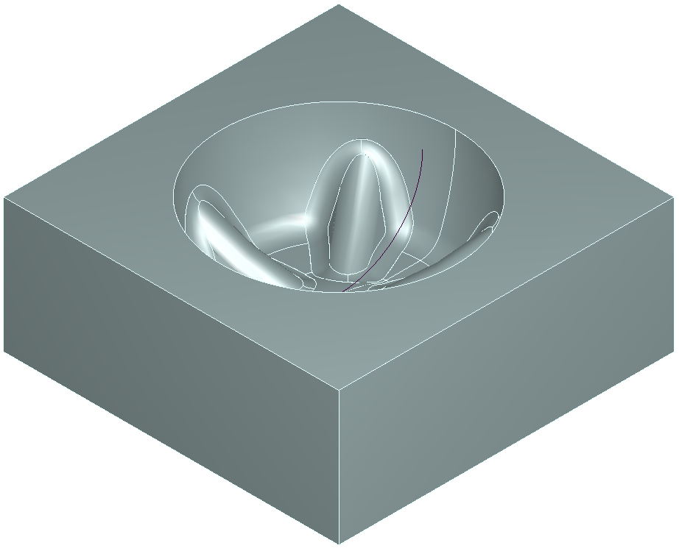

We need to create a surface to use as the flowline guide surface. We already have a curve in the center of the pocket. This will be spun around the Z axis to form a surface of revolution

- Select Create curves using curve wizard. Click Next.
- Set the Surface name to Control Surface
- Click on From Curves and Surface of Revolution.
- Click Next.
- Select the curve igs_7
- Set the Construction method to be Z-Axis
- Set the Start Angle to 0 and the End Angle to 360

The completed form should now look like this
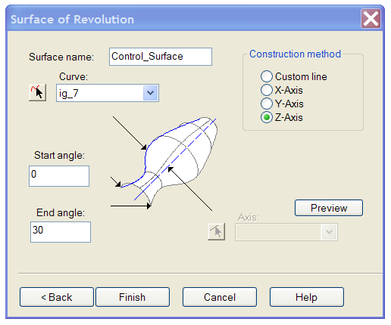

- Click Finish.
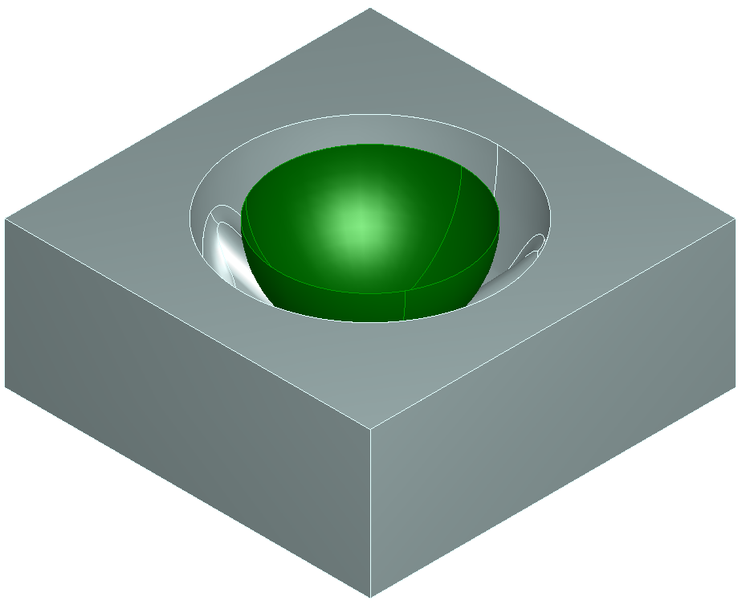

The new, hemispherical control surface is positioned in the center of the pocket.

- Select and hide the control surface.
- Select the remaining surfaces
- Create a feature of type Surface milling.
- Press next twice.
- Select a Single Operation and press next.
- Select Flowline and press Finish.
- Edit the feature.
- Click on Flowline and select Surface Control.
- From the pulldown select Control_Surface
- Ensure that the machining direction arrows appear as shown below, if not use the switch machining side button

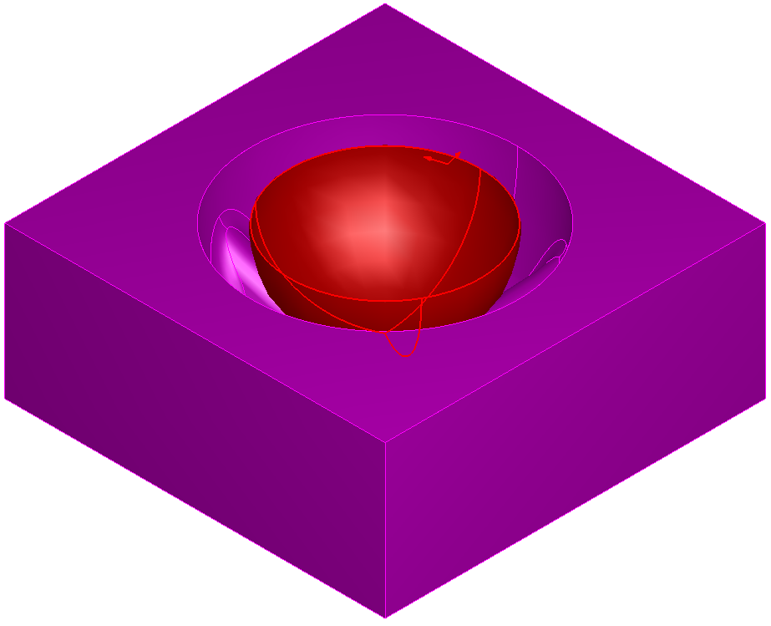

- Check that the form is filled in as below and press Apply.
- Click on finish 1 and select the Milling tab.
- Set the Stepover to be 0.5mm, press Apply and OK.
- Hide the control surface.
- Run a centerline simulation

The finished toolpath runs smoothly down the pocket giving an even surface finish.

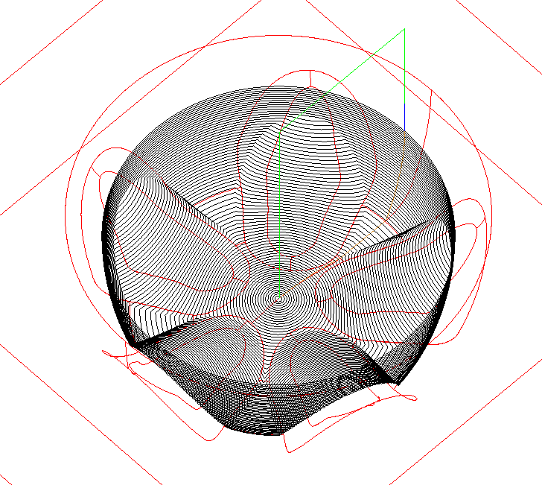

Undercut Flowline Machining Example 2

In this example flowline machining will be used to machine a port on a manifold. The use of flowline machining together with a lollipop cutter allows the user to achieve an even surface finish on a difficult part without the use of 5 axis strategies. By machining along the port the machining cusps are aligned with the gas flow direction giving better flow properties and ease of polishing.

- Open a millimeter milling document.
- Open the model manifold.fm

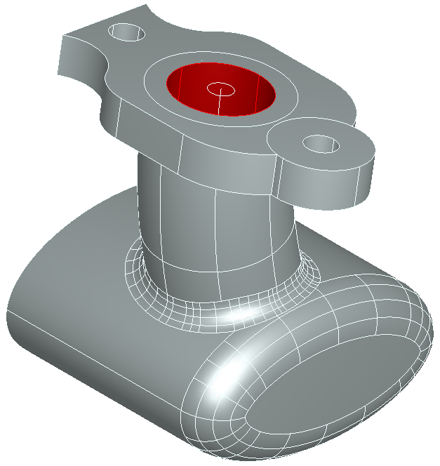

The part has been positioned so that the undercut is as small as possible. We are going to machine the port which is highlighted in the image above.The first step is to create the flowline control surface from the circle and centerline curve provided.

- Select Surfaces from the Steps view.
- On the surface wizard check From curves and Swept surface.
- Press Next.
- Change the Surface name to Control_surface.
- Set the Axis to ig_25
- Click the curve selector next to Cross section
- Select the circle at the top center of the port (circ3).
- Check Sweep from other end.
- Press Preview.

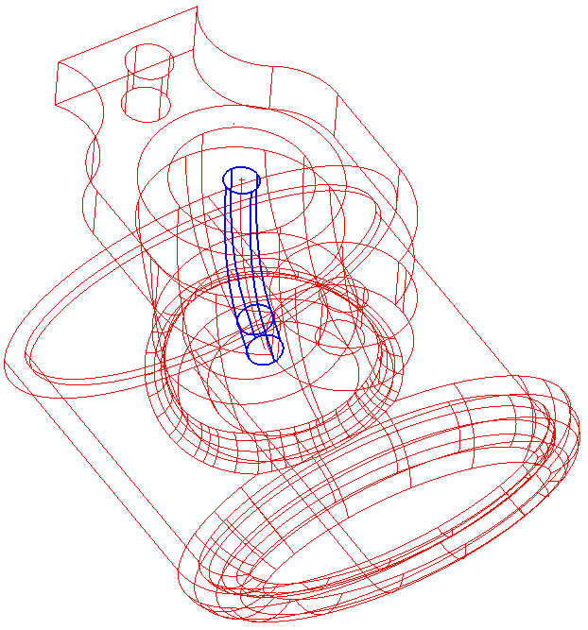
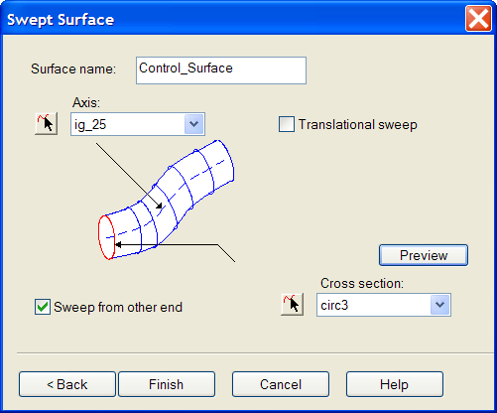

The preview surface should appear down the center of the port as shown above right

- Press Finish.
- Create a Feature.
- Check Surface milling and press Next.
- Select the 8 surfaces that form the inside of the port and add to the feature, then press Next.
- Check Choose a single operation and press Next.
- Check Flowline then press Finish.
- Edit the Feature.
- Click on Flowline and select the Surface control tab.
- From the pulldown select the surface Control_Surface.
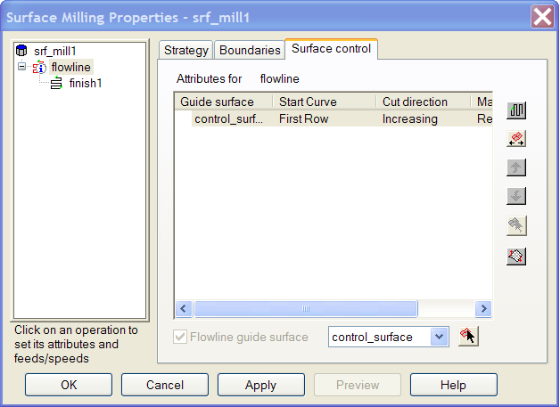

- Use the Isoline set row/column and Switch machining side buttons to get the machining direction arrows pointing down and out from the control surface as shown below.

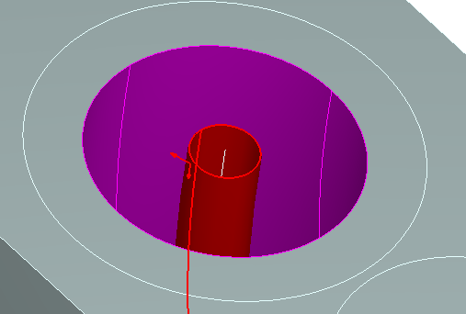

- Click on finish 1
- Select the Tooling tab.
- Select the tooling group Side Mill.
- Select the tool Lollipop.
- Click on the Milling tab.
- Set the Stepover to 0.5
- Click on the Leads tab.
- Change the Stepover type to Loop.
- Change Use Lead-in/out to On first plunge/last retract.
- Change Lead-in/out plane to Normal to surface.
- Check Use arc lead-in/out
- Set Ramp Diameter to 15, Ramp-in angle to and Ramp-out angle to 90.
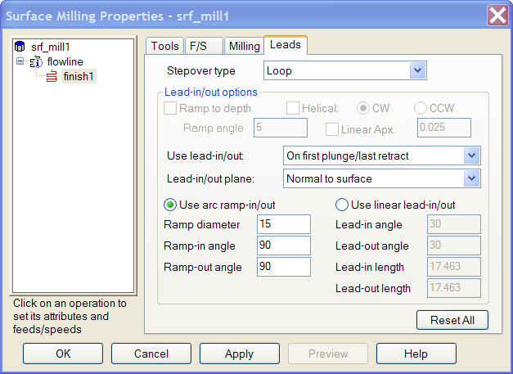

- Press Apply and then OK.
- Run a Centerline simulation.
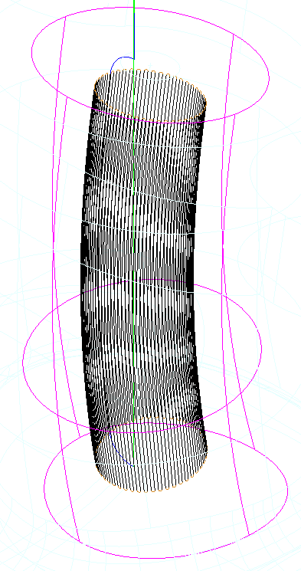

The port has now been finish machined. By using flowline machining with a control surface that follows the form of the port we have achieved an even stepover. Note how the lead-out move ensures that the tool clears
the job on the retract move.

Isoline Machining

Isoline machining is a finishing technique that machines each surface in a part individually. This gives the user a greater degree of control over the cutting direction and surface finish than other methods. In this example we shall machine a die for a jug.

- Open the part Isoline.FM
- Select an isometric view.

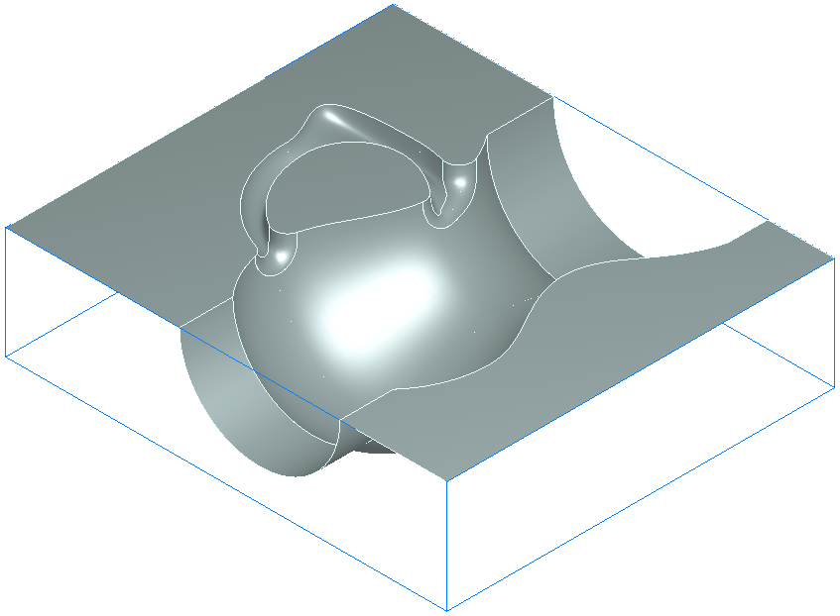
This part contains nine surfaces. Roughing strategies to clear out the bulk of the stock have already been set up. Then we will now create an isoline finishing strategy for the surfaces.

- Click on Part View.
- Edit the Feature srf_mill1.
- Click on the Process tab and then on Add an Operation.
- On the New strategy form select Isoline.
- Click Finish.
- On the Process tab uncheck Z Level to suppress the roughing operations.
- Click on finish4 in the tree view and select the Tooling tab.
- Select a 5mm diameter ball nosed tool and press Apply.
- Click on the Milling tab and set the stepover to 0.75mm.
- Click Apply.

In this case we only want to finish the curved surfaces. It is assumed that the flat top of the stock will be finished by another process such as surface grinding. We therefore need to remove these surfaces from the list of surfaces to be machined.

- Click on Isoline in the tree view and select the Surface control tab.
- Uncheck the surfaces ig_shell1, ig_shell3 and ig_shell5.
- Press Apply and then OK.
- Run a Centerline simulation.

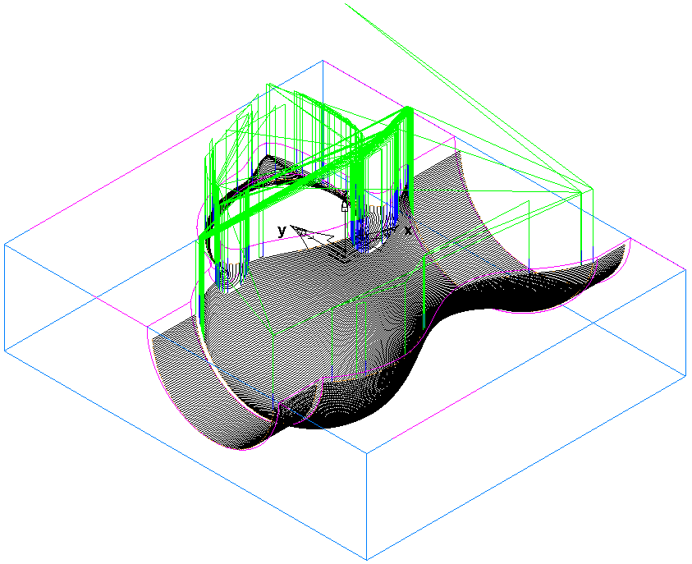

The toolpaths should appear as in the picture above. Note how the toolpaths follow the shape of the surface. We will now modify the order in which the surfaces are machined and direction in which they are cut. This is being done in order to give better cutting conditions in the narrow sections and a better surface finish overall.

- Edit the feature.
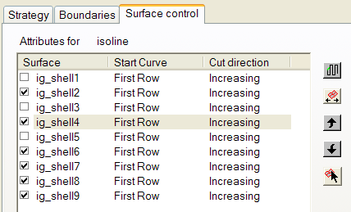
- Click on Isoline in the tree view and select the Surface control tab.

The surfaces are machined in the order in which they appear in the surface control list. Surfaces may be moved up or down the list by selecting them and then using the up and down arrows to the right of the list

- Using this method, place the surfaces into the order shown below.

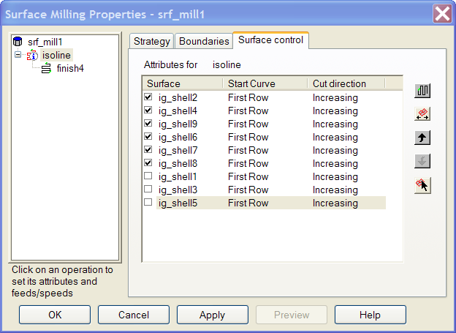

- Click Apply and then OK.
- Run a Centerline simulation to see how the order in which the surfaces are machined has been changed.

We will now consider how to get the best surface finish and shortest machining time by changing the cutting directions from the defaults. The stepover set in Isoline machining is the maximum stepover. Where a surface is getting wider and narrower, the stepover will apply at the widest point on the surface. As the surface narrows, so will the stepover. This may result in a longer than necessary toolpath and over machining where the isolines are very close together. For example on the jug body the stepover is varying between 0.5mm and 0.2mm.
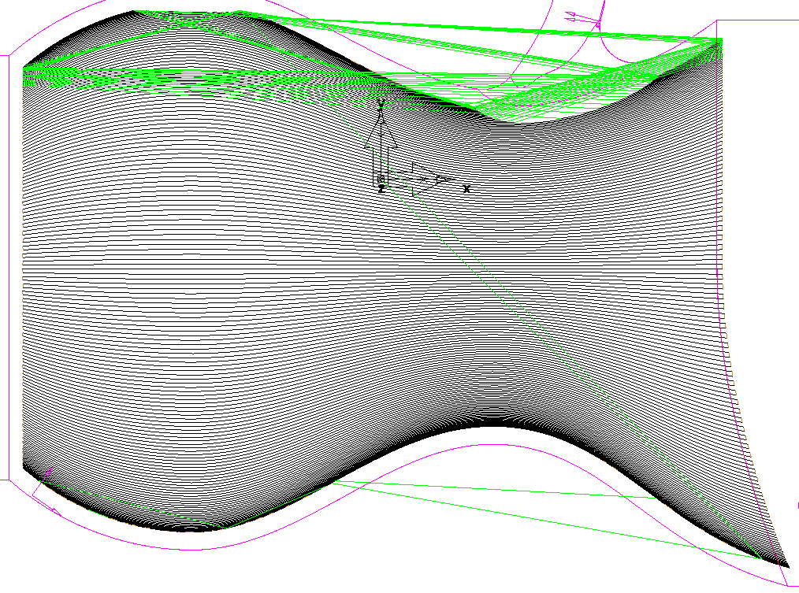

- Edit the feature.
- Click on Isoline in the tree view and select the Surface control tab.
- Click on ig_shell9 in the surface control list.

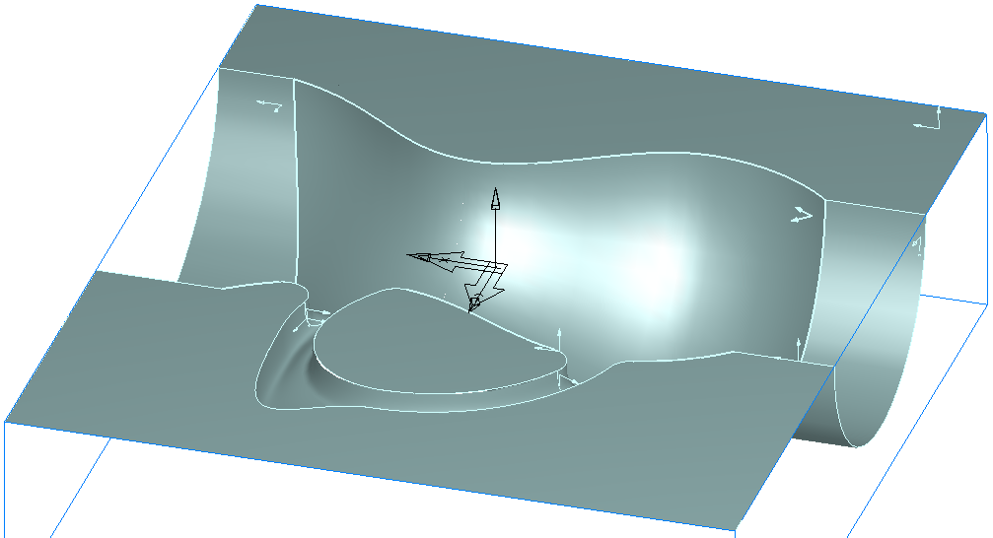
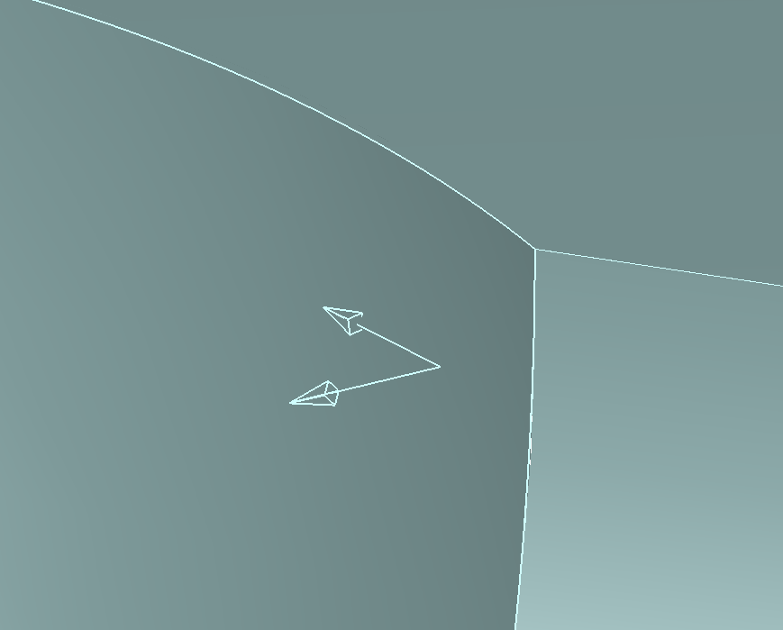

The pair of arrows on each of the surfaces show the surface normal and the direction of the first cut.

- Click on the Set isoline row/col button until the arrows on the jug body are aligned as shown below.
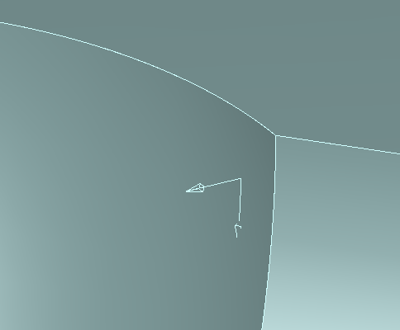

The first pass will now start in this corner and cut around the body of the jug instead of along. This will give a constant stepover.

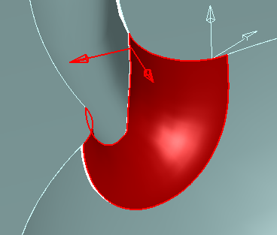
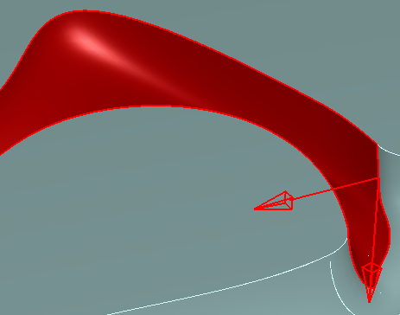
- Repeat this process for ig_shell6, ig_shell7 and ig_shell8 aligning the cutting directions as shown below.
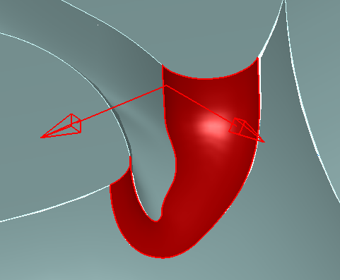
ig_shell6 ig_shell7 ig_shell8

- Press Apply and then OK.
- Run a Centerline simulation to see the new cutting strategy.

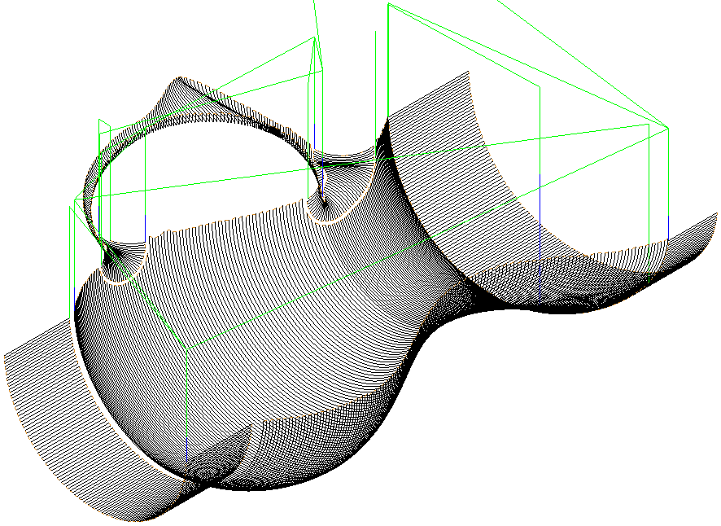

- Edit the feature
- Click on srf_mill 1 in the tree view.
- Click on the Process tab.
- Check the Z Level operation to unsuppress it.
- Press Apply and then OK.
- Run a 3D simulation to see the surface finish.

